TASK | Lubrication of fork truck chains (aerosol application)
LOCATION OF USE | Workshop and field engineers |  | Assessment  No |  | 008
PRODUCT NAME | Chain Lube |  |  |  | 008
DESCRIPTION OF SUBSTANCE | Aerosol can with chain Lube used to spray onto chains (Masts etc) |  |  |  | 008
MANUFACTURER | SEH Logistics |  |  |  | 008
MANUFACTURERS CONTACT | Unit FFB 9  Bonehill Farm  Tamworth  Staffordshire. B78 3HP  Tel: 07725 041331 |  |  |  | 008
ASSESSOR | Martin Monaghan CMIOSH |  | Date |  | 23 07 24
TITLE | Health and Safety Consultant |  | Review by |  | 23 07 26
Personnel Performing Task  (Please list below)  Technicians/ Fitters/ Workshop Operatives |  | Time Spent  (Minutes/day)  As and when required, amounting to a few minutes per day | Training Given 
 |  |  | Yes

MSDS Revision Date | Hazard Statement
04/07/2014 | H222 Extremely flammable aerosol.  H412 Harmful to aquatic life with long lasting effects.  H229 Pressurised container: may burst if heated

Assessment to be conducted in Association with Hazard Data Sheets, a full current copy of which must be attached to this assessment.

Please denote the hazardous properties of the substances used in the task with a

NEW INTERNATIONAL GLOBALLY HARMONISED HAZARD SYMBOLS
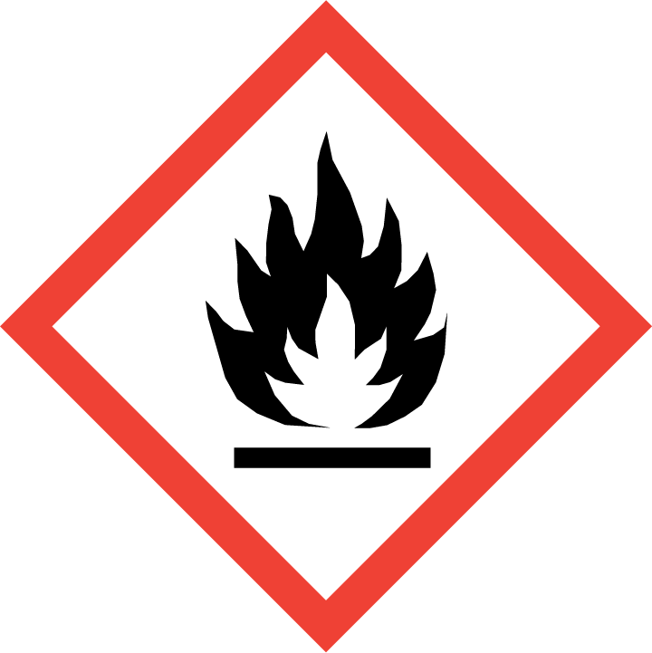 | 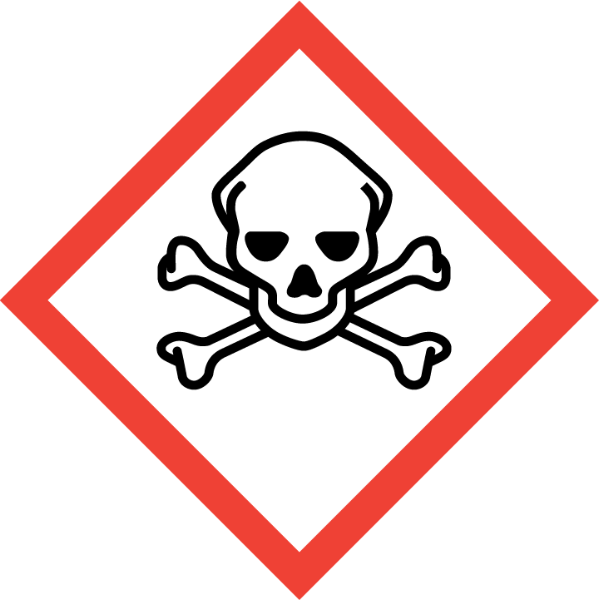 | 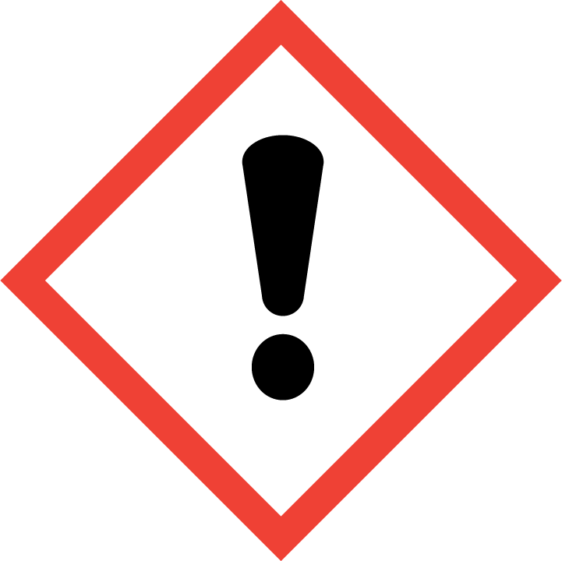 | 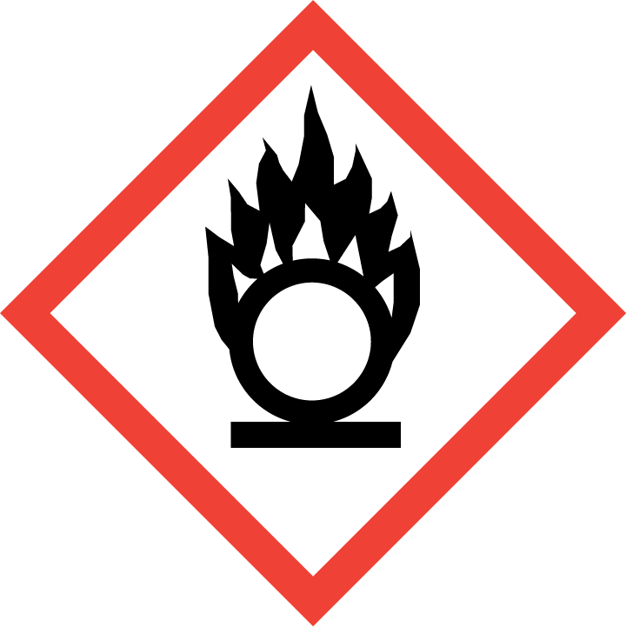 | 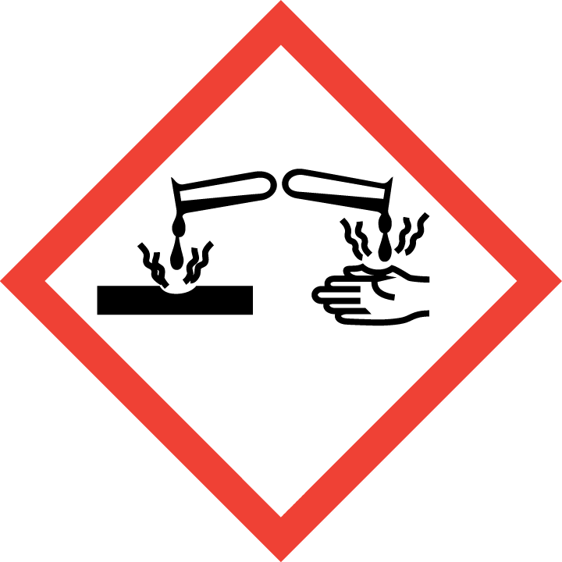 | 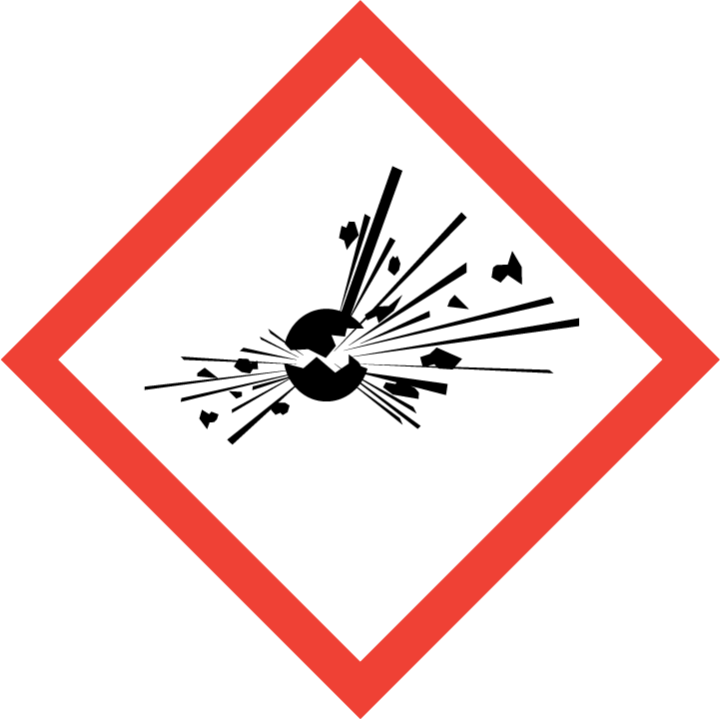 | 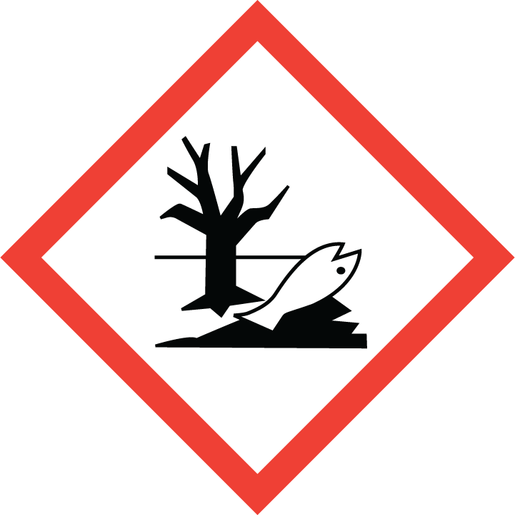 | 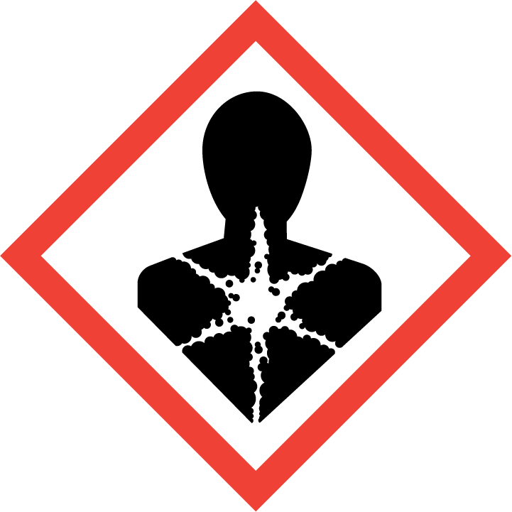
Flammable | Toxic | Harmful | Oxidising | Corrosive | Explosive | Harmful to the environment | Health Hazards i.e. respiratory sensitisation or carcinogenicity

SMOKING, EATING AND DRINKING ARE PROHIBITED IN THE WORK AREAS.
Information, Instruction and Training must be provided to all users. Young Persons, New or Expectant Mothers and other vulnerable groups must not use or be exposed to this product.

WORKPLACE EXPOSURE LIMITS (WEL’s)
No occupational exposure limits assigned for this product.

IMPORTANT!
Refer to Workplace Exposure Levels information provided in the Manufacturers Safety Data and revise control measures if exposure levels likely to be reached.

ROUTE OF EXPOSURE
Skin |  | Eyes |  | Inhalation
Ingestion |  | Cuts/abrasions |  | Systemic

PERSONS AT RISK
User of product |  | Co workers |  | Members of the public

ROUTE OF EXPOSURE |   FIRST AID MEASURES
Eyes | Rinse immediately with plenty of water. Remove any contact lenses and open eyelids wide apart. Continue to rinse for at least 15 minutes. Continue to rinse for at least 15 minutes and get medical attention.
Skin | Remove contaminated clothing immediately and wash skin with soap and water.
Inhalation | If spray/mist has been inhaled, proceed as follows. Move affected person to fresh air and keep warm and at rest in a position comfortable for breathing. If breathing stops, provide artificial respiration. Keep affected person warm and at rest. Get medical attention immediately
Ingestion | Rinse mouth thoroughly with water. Do not induce vomiting. Get medical attention.
In all cases of doubt, or if symptoms persist seek medical attention. Never give anything by mouth to an unconscious person. If unconscious, place in recovery position and seek medical advice.

PERSONAL PROTECTIVE EQUIPMENT
 |  |  |  | 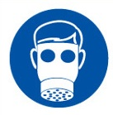 |  | 
YES | YES | YES/NO |  | YES/NO | YES | YES/NO
YES | YES |  |  |  | YES - Chemical Resistant

HANDLING | STORAGE | TRANSPORT | DISPOSAL
Keep away from heat, sparks and open flame. Eliminate all sources of ignition. Do not spray on a naked flame or any incandescent material. | Store in a cool location in rear of vehicle away from heat sources and direct sunlight. Ensure cans are stowed securely with the lids firmly on. Store in flammable store when at factory. | Only carry minimum required amounts (1 can). Carry secured upright within the vehicle away from direct sunlight. | Must not be disposed of with household waste. Used, degraded or contaminated product may be classified as hazardous waste. Return empty aerosols to the factory for disposal.

REQUIRED CONTROL MEASURES
- Ensure only minimum amounts are transported and used (1 can).
- Ensure approved impermeable gloves are used at all times
- Ensure overalls are worn and these are suitably laundered.
- Ensure suitable chemical resistant goggles are worn when spraying lubricant.
- Ensure that work is undertaken in well ventilated areas, where significant spray is required ensure a suitable vapour/particle respirator is used.
- Do not apply near walkways and clear any areas of overspray.
- Ensure that Engineers are equipped with antibacterial hand washes and wipes and that good hygiene practices are enforced.
- Provide engineers with suitable barrier creams.
- Ensure that the aerosol is always used with the straw attachment to reduce the risk of overspray.
- Do not apply near heat sources or sources of ignition.

FIRE PRECAUTIONS
Extinguish with foam, carbon dioxide, dry powder or water fog.

ACCIDENTAL RELEASE/SPILLAGE PROCEDURES
Provide adequate ventilation. Use suitable respiratory protection if ventilation is inadequate. Avoid inhalation of vapours

MONITORING REQUIREMENTS AND HEALTH SURVEILLANCE
Health surveillance is not in place for workers exposed to this product.

